Name : Oluwabusolami Ogunbambi
Student NO: 2104006
Module no: 6CS010 Digital Forensics
Contents
1. Case Information 1
2. Tools Used 1
3. Evidence Acquisition 2
4. Evidence Analysis 2
5. Conclusion 16
7. Investigator's Signature 17
8. References 17

1. Case Information
- Case Number: 1
- Investigator Name: Oluwabusolami Ogunbambi
- Date of Investigation: 30/12/2024
VM Snapshot Details: Z- Security, an elite digital forensics company in the UK was invited to investigate a recent security incident involving suspected criminal activities taking place in a medium- sized company called UBB. I was hired to physically investigate some of the affected assets. Network administrators at UBB identified unusual P2P and encrypted traffic that is rarely needed to support their business processes. An early investigation of some of their system logs confirmed suspicious connections some of which bypassed their firewall rules. I was then given a Virtual Machine snapshot to investigate.

2. Tools Used
Software:
- Autopsy
- Microsoft word
- Snipping tool to capture screenshots
Hardware
- Laptop
- Wi-Fi router
Other equipment
- Chair
- Table

3. Evidence Acquisition
- Snapshot Integrity Verification:
  - Verification Method: The snapshot was given directly to Z-Security directly from the company UBB so therefore it has already been verified by UBB
- Chain of Custody Documentation: The chain of custody will be documented as a table for each evidence item.

4. Evidence Analysis
EVId-001
Evidence ID | Evidence description | Source/location | Acquisition  date and time | Acquisition method | Key findings about the evidence
evd-001« | Examination of Emails | web history and cookies | 2/12/2024 | The VM was analysed with autopsy and the email was extracted | Discussion to bypass firewalls
 | Company
 | agent
 | Current investigator

Evid-001 contains screenshots showing email communication between enjanesnow@yandexmail.com and enjohnsnow@gmail.com. The evidence captures the user’s intentional effort to find and use an email service that they believe does not cooperate with law enforcement.
Details of the Evidence
- Search for Secure Email Services:
  - The user begins by browsing Reddit, looking for email providers described as “not compliant with the feds.” This search suggests they are specifically seeking secure email services that avoid sharing user data with authorities. A screenshot of this Reddit activity is included as part of the evidence.
- Choosing Yandex Mail:
  - After exploring options, the user navigates to Yandex Mail, a Russian email service. Screenshots show the user visiting the Yandex website, indicating their decision to use this platform, likely due to its reputation for operating outside Western law enforcement jurisdiction.
- Email Communication:
  - The screenshots further show that the user creates a Yandex Mail account, enjanesnow@yandexmail.com, and uses it to communicate with enjohnsnow@gmail.com. This establishes their intent to switch to a platform they believe offers greater privacy.
Significance
The user’s actions demonstrate a clear intent to avoid surveillance by selecting an email service outside the reach of traditional law enforcement oversight. The screenshots provide a step-by-step account of their journey, from searching for secure email services to setting up and using a Yandex Mail account for communication.
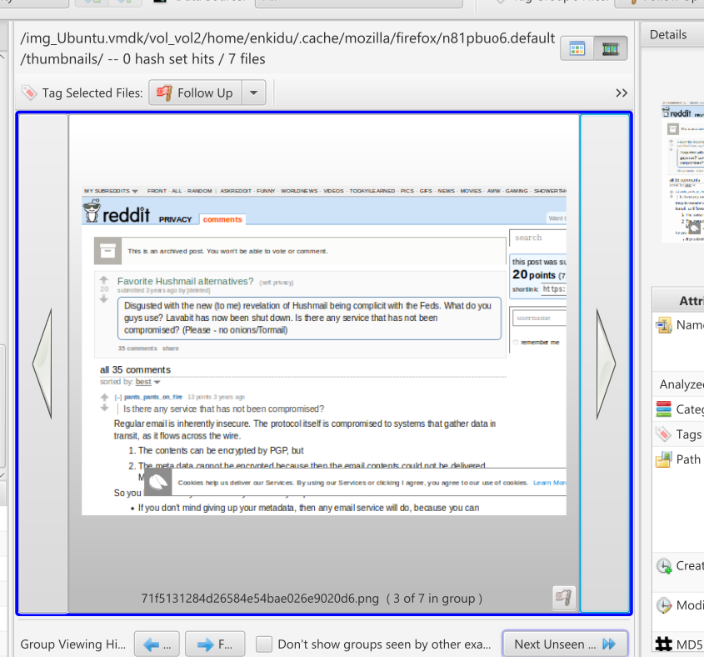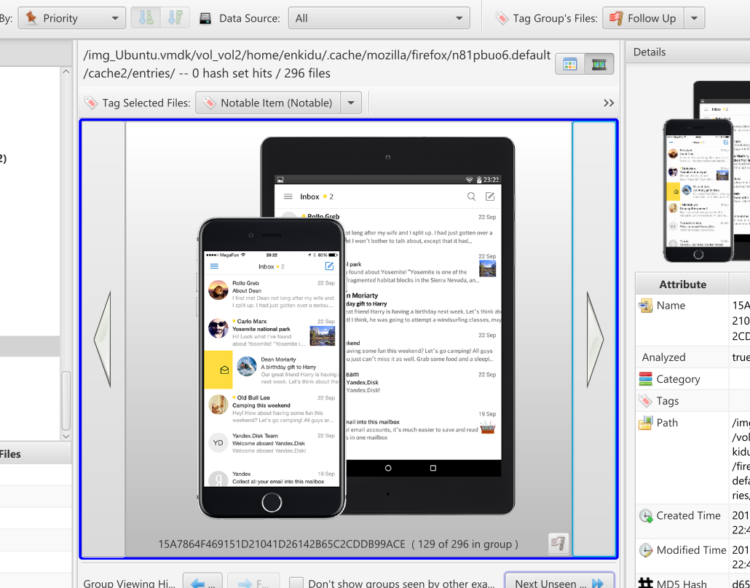
The examiner claims that on 17/092016, the user sends a set of commands to the corresponding email which are commands to delete critical files on a windows environment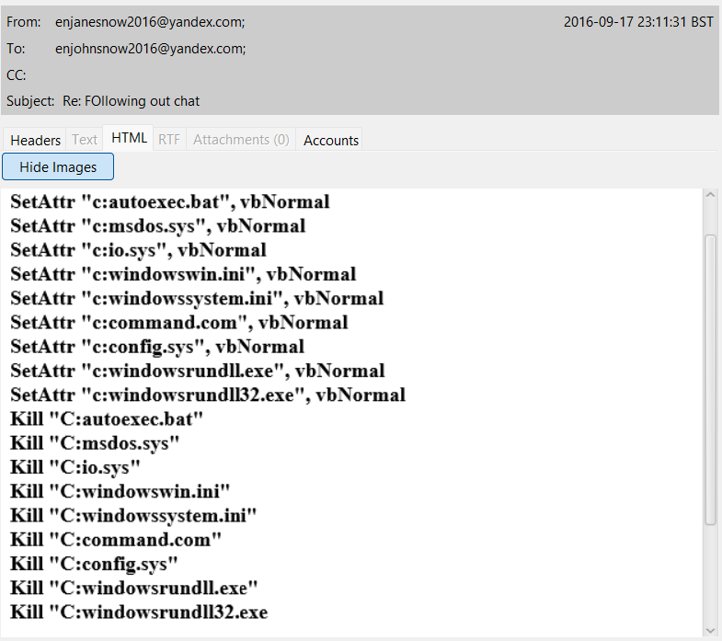

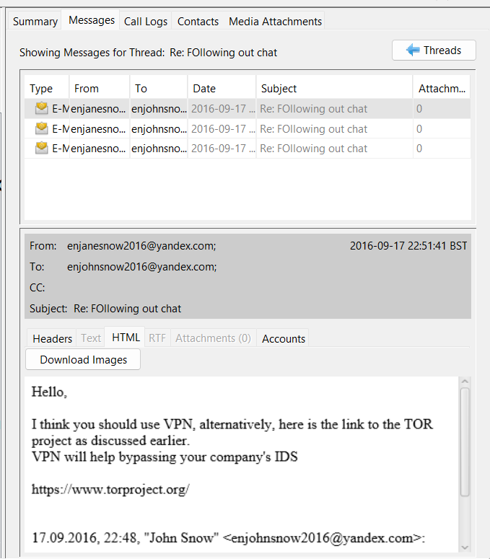
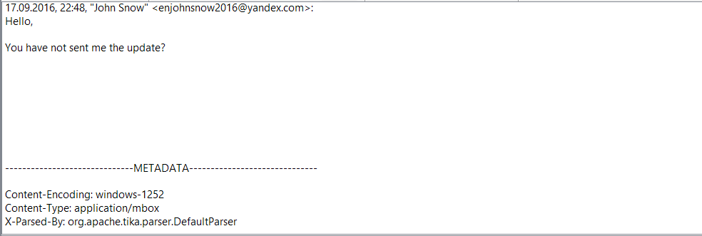
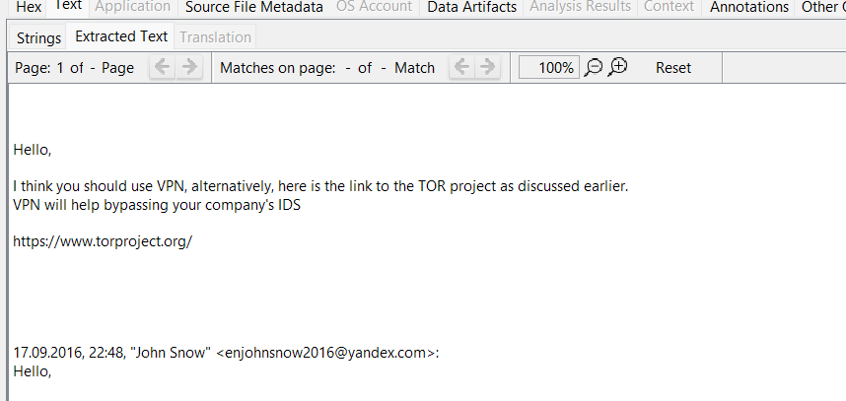Details of the Evidence
- Promotion of Unauthorized Access:
  - The screenshots reveal the user sending emails with instructions on accessing the Tor Project and recommending the use of a VPN to bypass UBB’s Intrusion Detection System (IDS) and firewall. These actions constitute a conspiracy to breach secure and unauthorized areas of the company’s network, which is a clear violation of UBB’s security policies.
- Disclosure of Sensitive Information:
  - The emails also indicate that the user has disclosed information about UBB’s IDS and firewall rules to a third party. This is a breach of confidentiality and a direct violation of the company’s policy on safeguarding proprietary security mechanisms. Sharing such critical information exposes UBB to unnecessary business risks, including the potential for misuse of the company’s systems and infrastructure.
Significance of the Violation
- Bypassing Security Measures: The user’s encouragement to bypass the IDS and firewall demonstrates malicious intent or gross negligence, both of which undermine the integrity of UBB’s security infrastructure.
- Exposure of Firewall Rules: Sharing details about UBB’s firewall configurations compromises the company’s cybersecurity posture and creates vulnerabilities that could be exploited by malicious actors.
Impact on the Company
- Increased Business Risk: The unauthorized disclosure of IDS and firewall details significantly elevates the risk of cyberattacks, data breaches, and other malicious activities.
- Policy Breach: These actions violate UBB’s policies regarding acceptable internet use, data protection, and network security.

Evid-002

Evidence ID | Evidence description | Source/location | Acquisition  date and time | Acquisition method | Key findings about the evidence
evd-001« | Examination of cookies ad cached files | OPT folder | 10/12/2024 | The VM was analysed with autopsy and deleted files were extracted | Accessing and downloading TOR browser
 | Company
 | agent
 | Current investigator

The screenshots provide evidence that the user successfully followed the instructions outlined in previous emails, resulting in the unauthorized download of the Tor Project software onto the system.
Details of the Evidence
- Confirmation of Unauthorized Activity:
  - The examiner reports that the user appears to have successfully acted on the instructions mentioned in earlier emails. This is corroborated by a screenshot showing the Tor Project software being downloaded onto the company system.
- Violation of Company Policy:
  - The download of Tor Project contravenes UBB’s policy, which explicitly prohibits the downloading of commercial software or copyrighted materials belonging to third parties without authorization. This breach is particularly concerning given the nature of the software, which is often associated with activities that require anonymized internet access.
Significance of the Violation
- Unauthorized Software Download: Installing software like Tor Project on a company system introduces potential security vulnerabilities and risks to the network.
- Policy Non-Compliance: The user’s actions violate established guidelines regarding acceptable use of company systems and software.
Impact on the Company
- Increased Security Risks: The use of anonymizing tools such as Tor can bypass monitoring and create vulnerabilities within the company’s network, potentially allowing unauthorized access or data exfiltration.
- Legal and Compliance Issues: Downloading copyrighted or third-party software without proper licensing could expose UBB to legal liabilities.
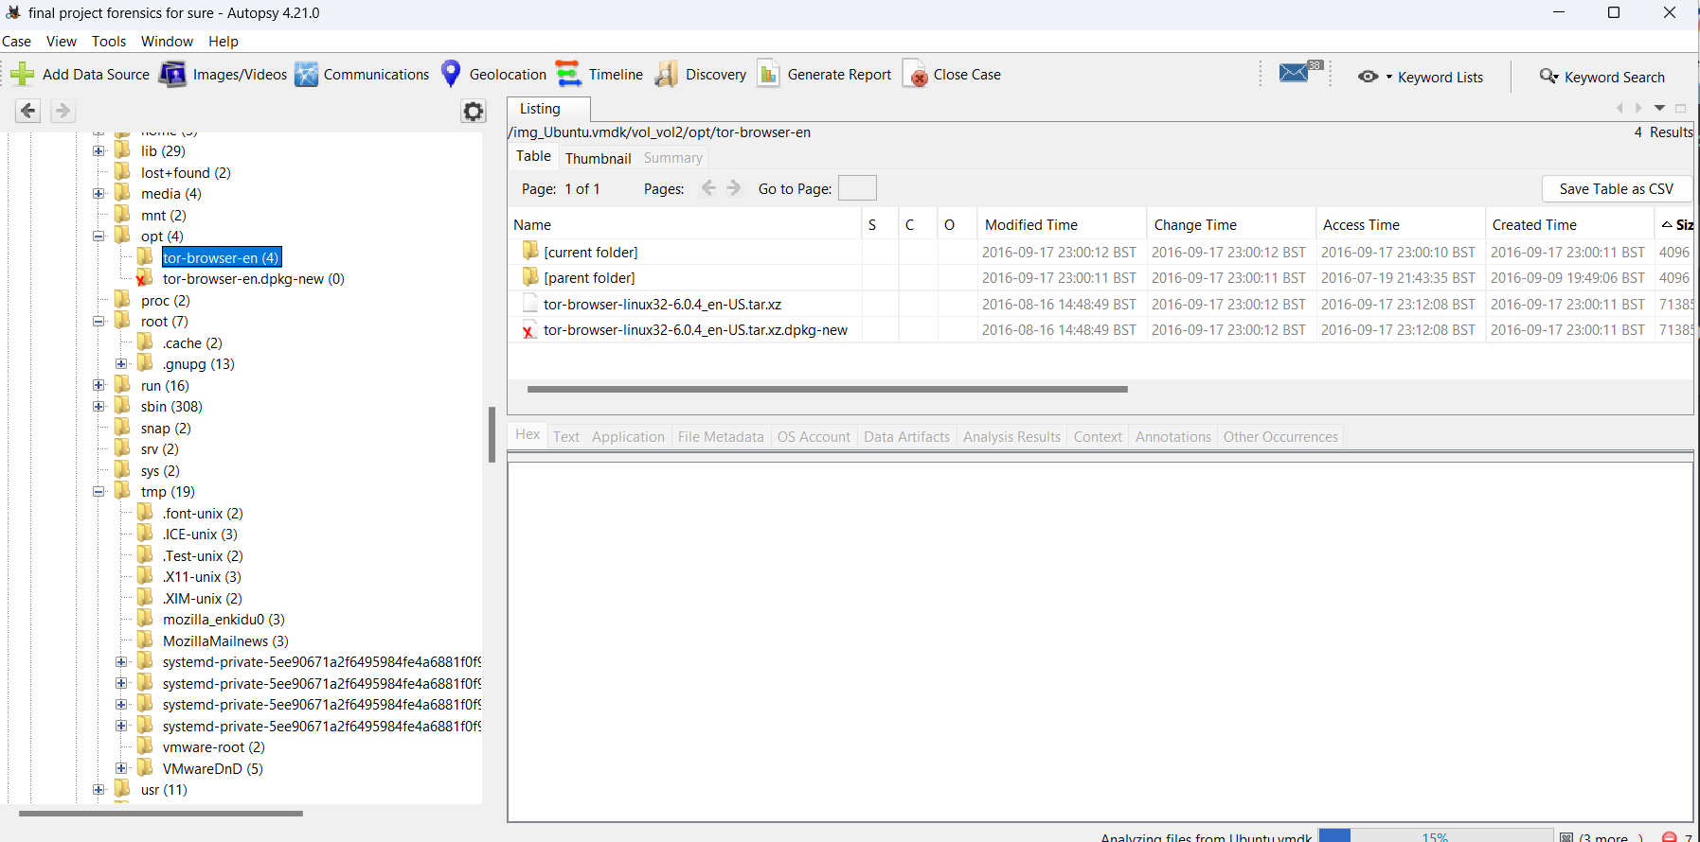
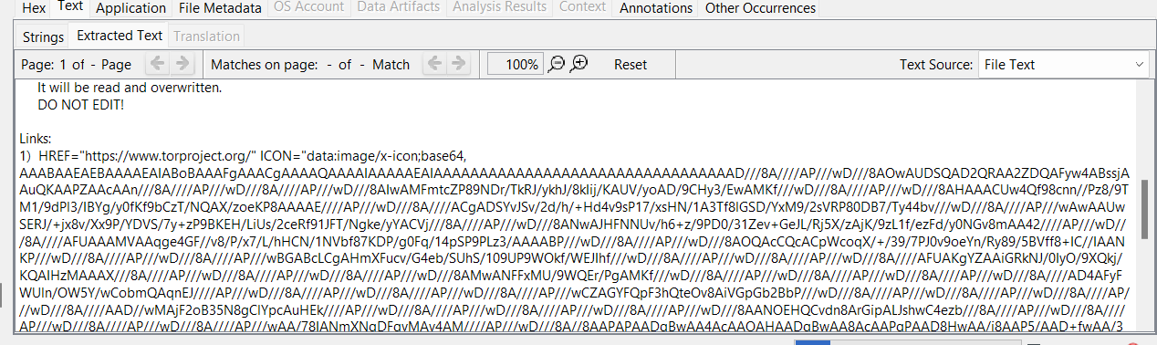
The screenshot below provides evidence that the user accessed an onion link, which constitutes a violation of the company’s internet usage policies and poses potential risks to the organization’s systems.
Details of the Evidence
- Accessing Onion Links:
  - The examiner states that the user proceeded to visit an onion link, as captured in the screenshot. Onion links are associated with the Tor network and are known for hosting content that is often unregulated and potentially harmful.
- Violation of Internet Usage Policies:
  - Accessing onion links is a breach of the company’s policy on acceptable internet use, which prohibits visiting untrusted or high-risk websites. Such activities can expose the company’s systems to malware, phishing attacks, and other cyber threats.
Significance of the Violation
- Internet Misuse: Visiting onion links for non-work-related purposes violates company guidelines and represents misuse of company resources.
- Security Risks: Onion links are inherently less secure and can host malicious content, posing a threat to the integrity of the company’s systems.
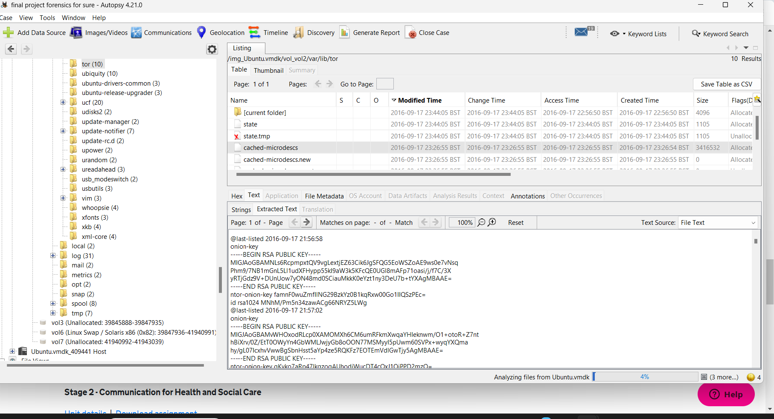
Evid-003
Evidence ID | Evidence description | Source/location | Acquisition  date and time | Acquisition method | Key findings about the evidence
evd-003« | Examination of carved files | $carved files | 13/12/2024 | The VM was analysed with autopsy and a carved files folder was created | Surfing the web for illegal drug buying websites
 | Company
 | agent
 | Current investigator

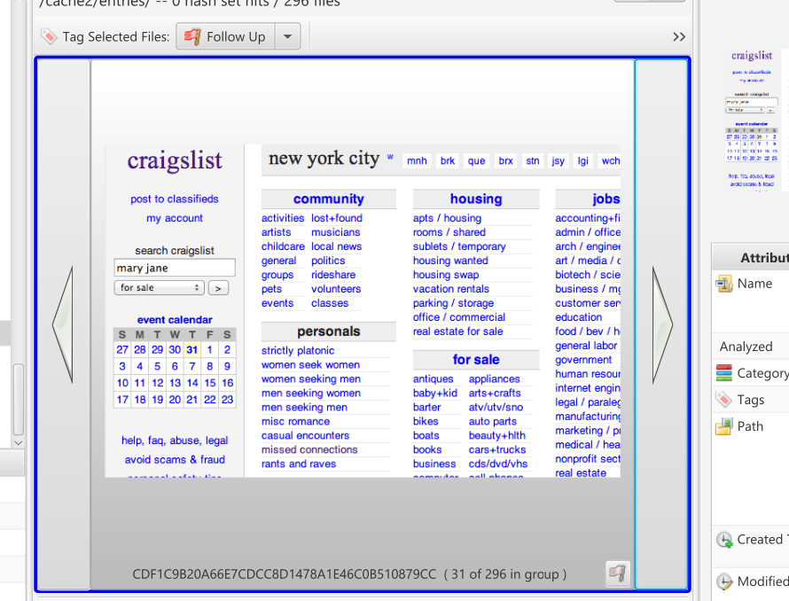 This screenshot indicate that the user conducted a search for "Mary Jane" on Craigslist, which is commonly recognized as a code name for the recreational drug marijuana.
Details of the Evidence
- Search Activity:
  - The examiner observes that the user appears to be searching for "Mary Jane" on Craigslist, as evidenced by the screenshots. This term is widely used as slang for marijuana, suggesting the user may be attempting to locate and purchase the substance.
- Implications of the Search:
  - This activity suggests a potential attempt to engage in the purchase of illegal substances, which is a serious violation of company policies and, in most jurisdictions, a breach of law.
Significance of the Violation
- Violation of Company Policy: Searching for and potentially attempting to purchase illegal drugs using company systems or during company time directly contravenes the organization’s policies on internet usage and employee conduct.
- Potential Legal Implications: If confirmed, this activity could implicate the company in illegal activities and expose it to reputational and legal risks.
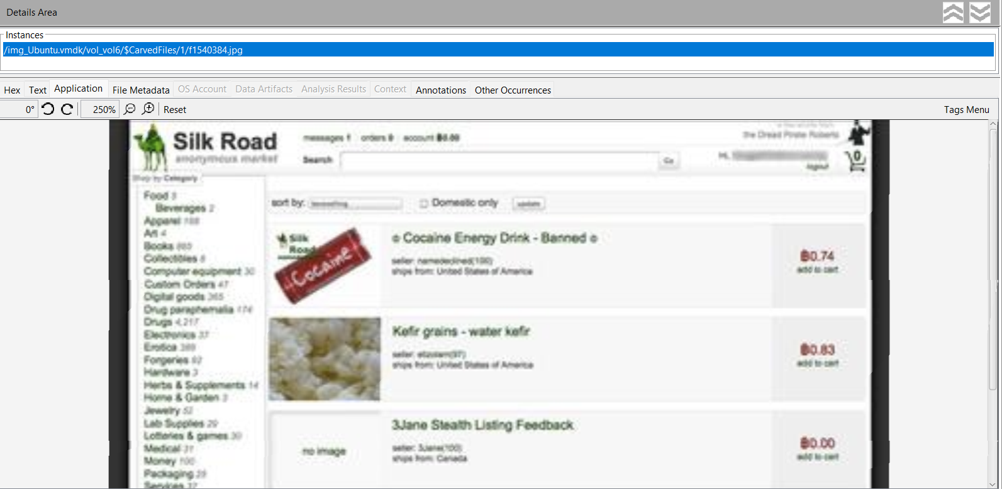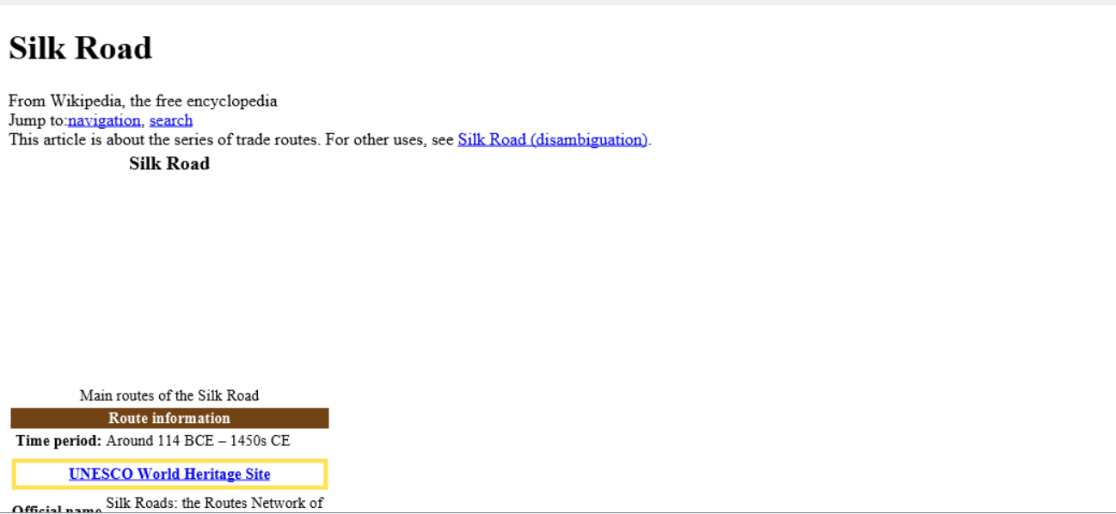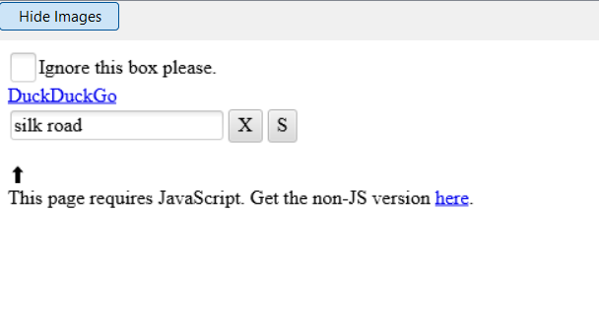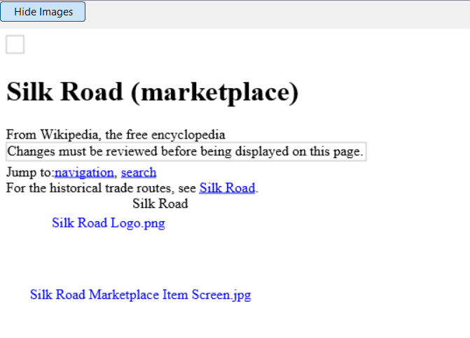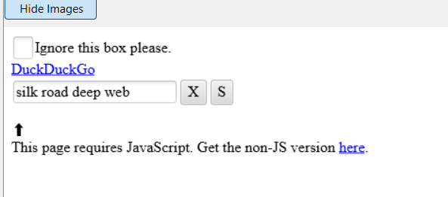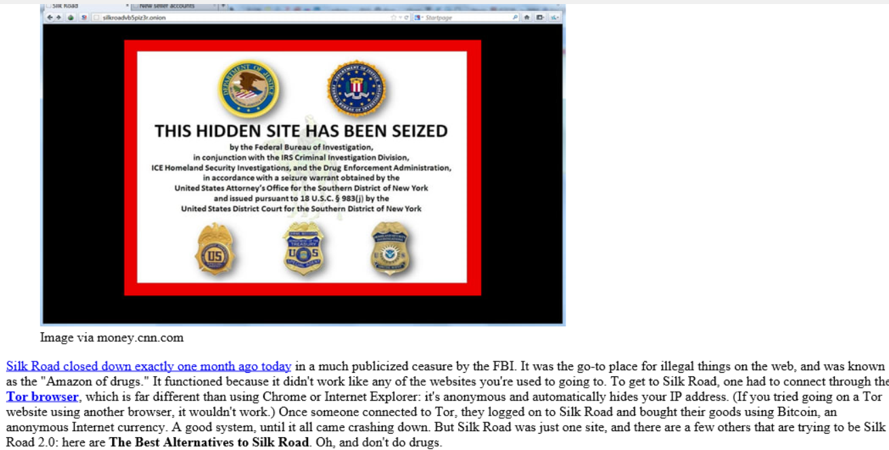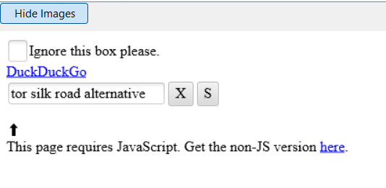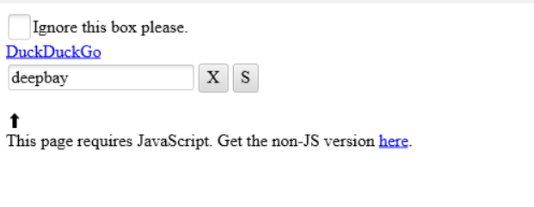
The screenshots provide compelling evidence that the user engaged in activities on the dark web, including accessing marketplaces like Silk Road and alternative platforms, with the intent to purchase illegal drugs. These actions constitute serious violations of company policies and applicable laws.

Details of the Evidence
- Dark Web Marketplace Searches:
  - The user searched for the infamous dark web marketplace Silk Road multiple times, as documented in the screenshots. This platform is widely known for facilitating the sale and purchase of illegal goods, including drugs.
  - Upon discovering that Silk Road had been seized by the FBI, the user searched for alternative dark web marketplaces, indicating a persistent intent to locate a functioning platform for illegal transactions.
- Use of TOR and DuckDuckGo:
  - The screenshots reveal that the user utilized DuckDuckGo, a privacy-focused search engine commonly paired with the TOR browser for accessing the dark web. This demonstrates that the user was actively leveraging anonymizing tools to browse and search for illegal marketplaces.
- Accessing Alternative Marketplaces:
  - Evidence shows that the user accessed several dark web marketplaces with the intent to purchase illegal drugs. These actions go against company policies and legal frameworks governing the use of company resources and compliance with criminal law.

Policy Violations
The user’s activities breach the following company policies:
- Visiting Prohibited Websites:
Accessing websites containing obscene, illegal, or otherwise inappropriate material.
- Acceptable Use of the Internet:
Using company systems to browse illegal or high-risk content violates the acceptable use policy.
- Avoiding Business Risks:
Creating unnecessary business risks through misuse of the internet jeopardizes the company’s cybersecurity and reputation.

Legal Violations
The user’s actions may also breach various national laws, including:
- Misuse of Drugs Act 1971 (UK):
Prohibits the possession, supply, or production of controlled substances without authorization.
- Computer Misuse Act 1990 (UK):
Covers unauthorized use of computer systems and accessing prohibited networks, such as those on the dark web.

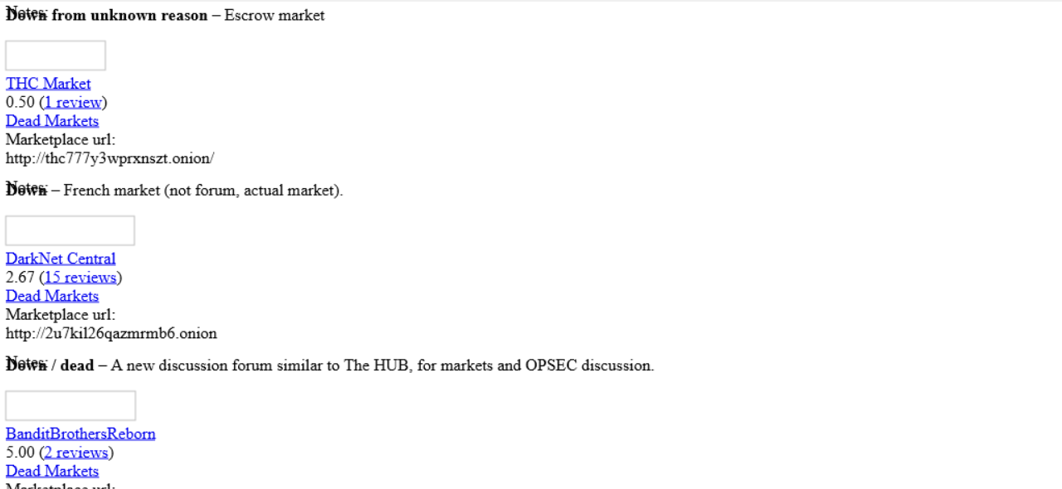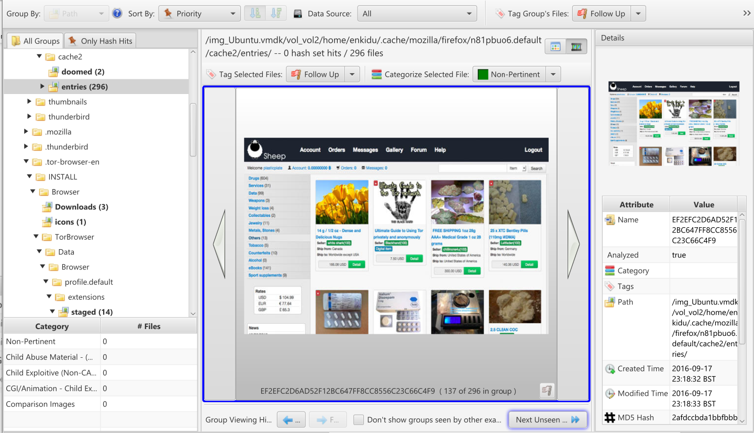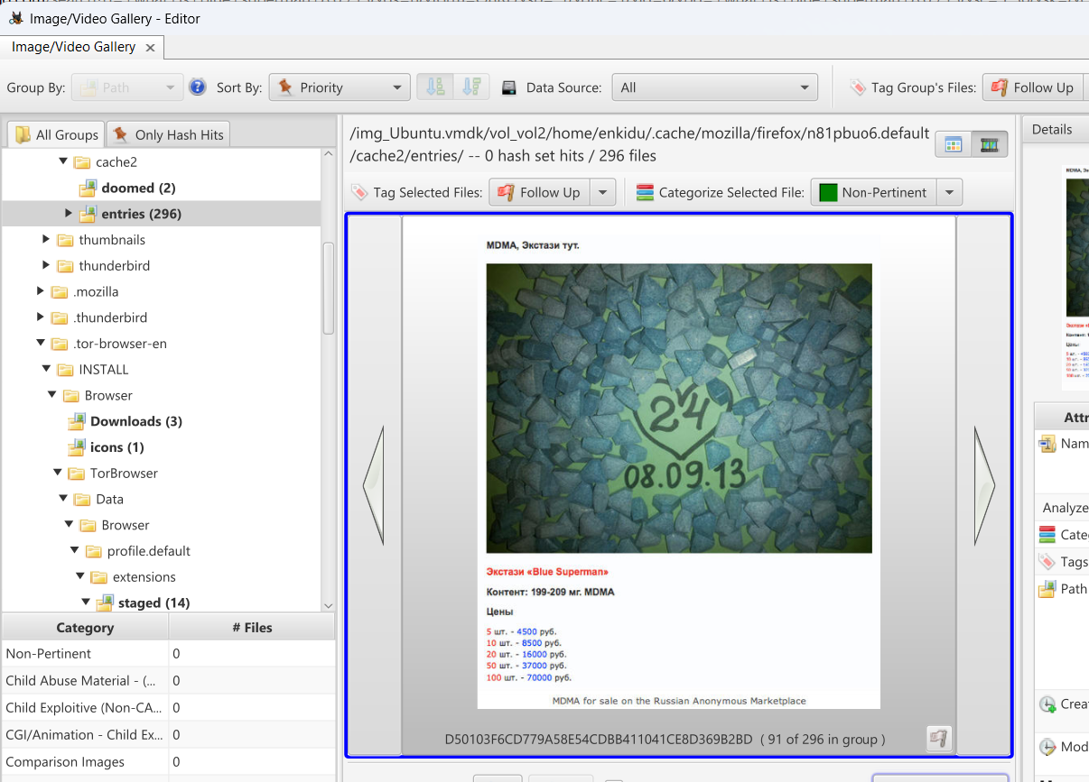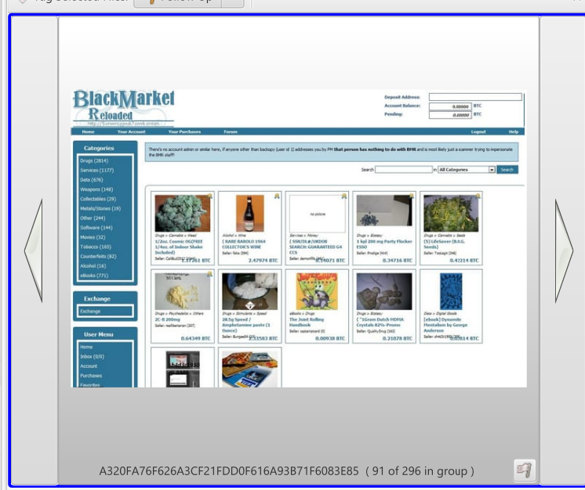
EVID-004
Evidence ID | Evidence description | Source/location | Acquisition  date and time | Acquisition method | Key findings about the evidence
evd-001« | Examination of Extracted photos | JPG files | 19/12/2024 | The VM was analysed with autopsy and the jpg files were extracted | Use of keyloggers
 | Company
 | agent
 | Current investigator

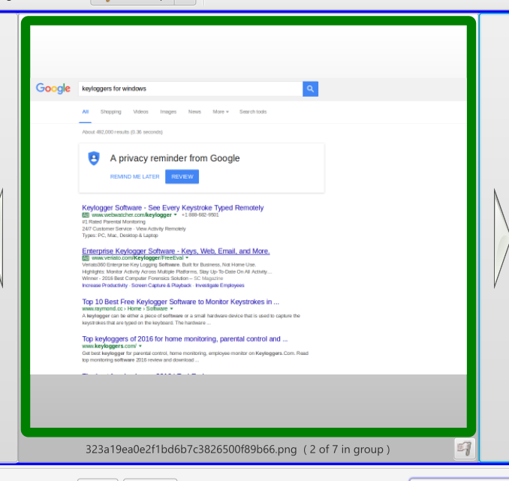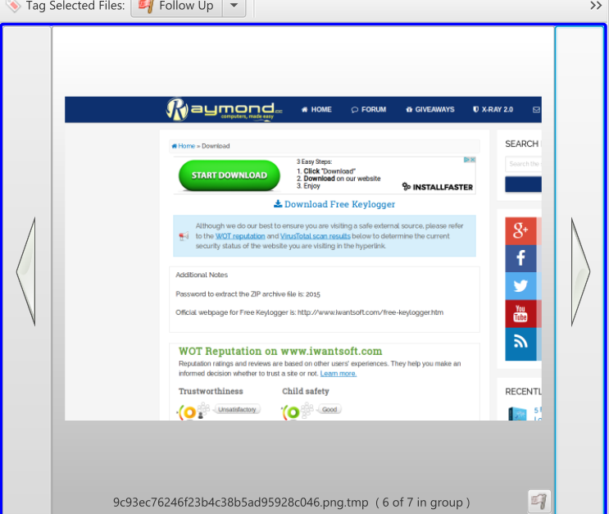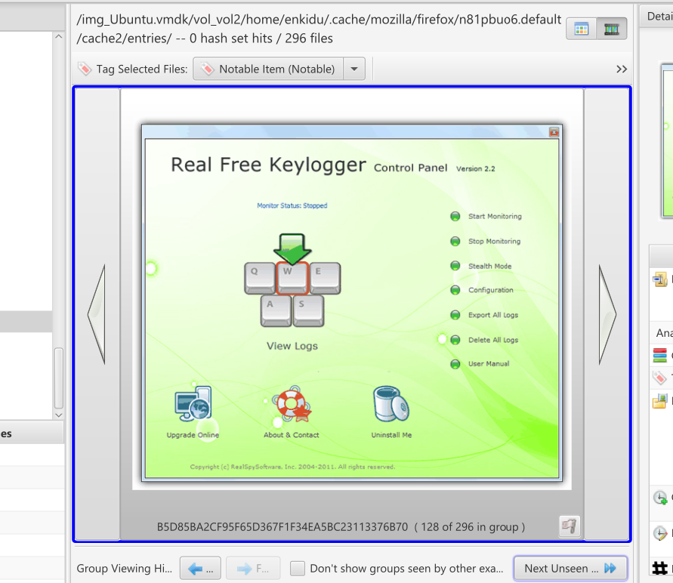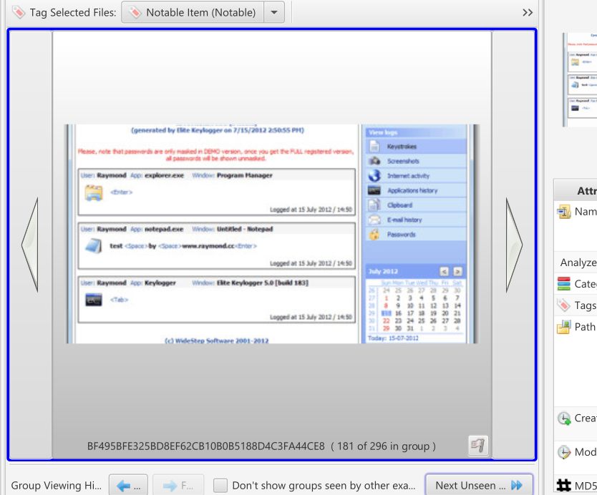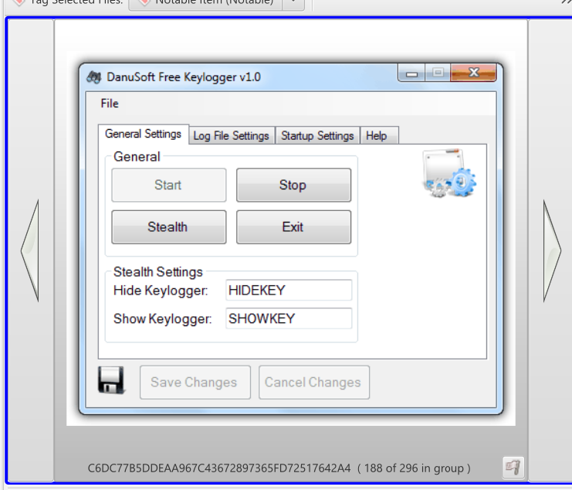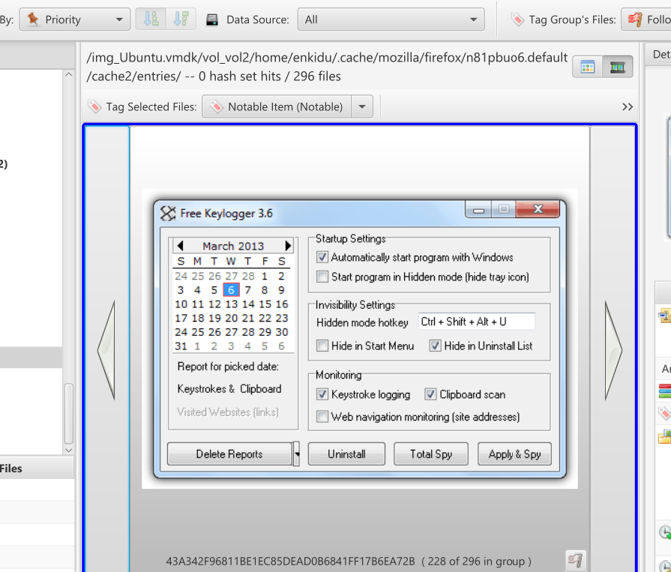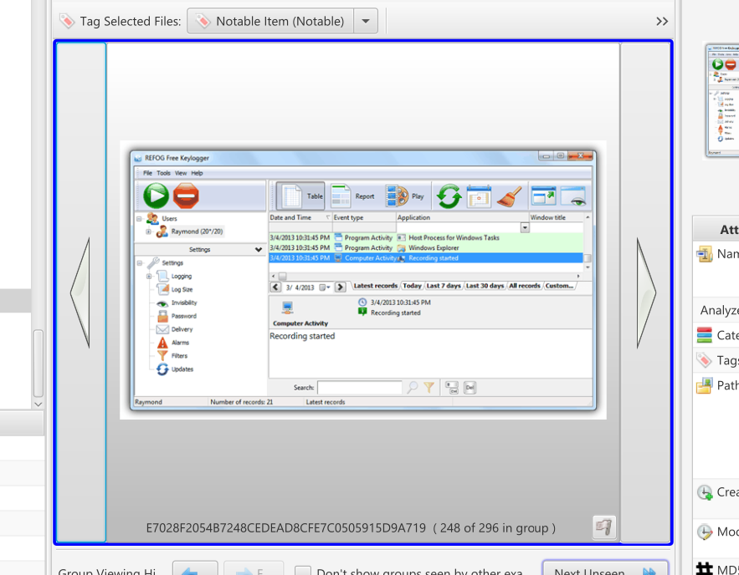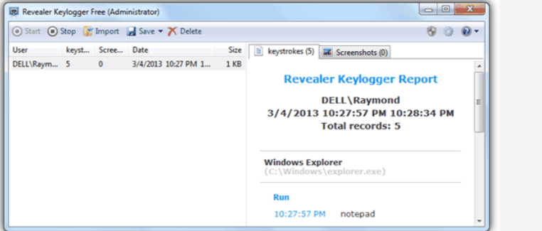
The screenshots provide clear evidence that the user not only searched for free keylogging software but also downloaded and used it, directly violating company policies and several data protection laws.

Details of the Evidence
- Search and Download of Keyloggers:
  - The examiner reports that the user searched for and successfully downloaded keyloggers, which are malicious tools designed to record keystrokes. Keyloggers can capture sensitive data, including login credentials, personal identification details, and other confidential information.
- Violation of Company Policy:
  - The user’s actions go against the company’s policies, which prohibit the use of unauthorized software like keyloggers. These tools undermine the security measures in place to protect company and personal data.

Policy and Legal Violations
The user’s actions breach several important regulations and laws:
- Company Policy Violations:
  - Data Protection: The use of keylogging software compromises the company’s duty to maintain data security and protect the privacy of sensitive information, such as login details and personal data.
  - Acceptable Use of Company Systems: Downloading and using keyloggers represents a severe breach of acceptable use policies and shows a lack of regard for the company’s IT infrastructure security.
- Legal Violations:
The use of keylogging software violates multiple legal frameworks, including:
  - General Data Protection Regulation (GDPR):
Under GDPR, companies are required to ensure that personal data is kept secure. The use of keyloggers, which capture sensitive information without consent, breaches this regulation.
  - Regulation of Investigatory Powers Act (RIPA) 2000 (UK):
The unauthorized interception or recording of data, including through keylogging, violates the provisions of RIPA, which regulates surveillance and interception of communications.
  - Computer Misuse Act 1990 (UK):
The use of keyloggers to capture keystrokes without authorization constitutes a criminal offense under the Computer Misuse Act, which prohibits unauthorized access to computer systems and data.
  - Telecommunications (Interception) Regulation:
The use of keyloggers to capture private communications, even if only keystrokes, can violate telecommunications interception laws, which protect the privacy of communication.

Impact on the Company
- Data Security Risks:
  - Keyloggers introduce significant risks to data security, potentially leading to unauthorized access to sensitive information such as passwords and personal details.

5. Conclusion
Summary of Findings
- The evidence collected demonstrates multiple instances of misuse of the company’s infrastructure, with serious implications for security, policy adherence, and legal compliance. Key violations include:
- Accessing Onion Links:
The user accessed onion links on the dark web, platforms known for illegal activities and untrustworthy content. This constitutes a breach of UBB’s policies on internet usage, particularly those prohibiting access to illegal or risky websites.
- Use of Keyloggers:
The user downloaded and used keylogging software, which is prohibited by company policy due to its potential for malicious activity, including unauthorized surveillance and data theft. Keyloggers also violate several data protection laws, including GDPR, the Computer Misuse Act, and the Regulation of Investigatory Powers Act (RIPA) 2000, by capturing sensitive information without consent.
- Online Shopping for Narcotics:
The user was found searching for and attempting to purchase illegal drugs through online marketplaces on the dark web. This activity not only violates company policies on internet use but also contravenes national laws, including the Narcotic Control Act (Canada) and the Misuse of Drugs Act 1971 (UK), making the behaviour both illegal and highly damaging to the company’s reputation and operations.
- The actions of the user represent serious breaches of UBB’s internal policies and compliance with legal frameworks. The misuse of company resources for illegal activities such as accessing the dark web, using malicious software, and attempting to purchase illegal drugs exposes the company to significant cybersecurity risks, legal liabilities, and reputational harm.
- As these actions involve violations of company rules and multiple laws, it is recommended that the user be held accountable under the law. This includes prosecution where applicable, to mitigate risks to the company and uphold compliance with relevant regulations. Immediate action is required to address the breach, safeguard company assets, and ensure future compliance with both internal policies and the law.

7. Investigator's Signature
“this section is to sign off the case”
- Name: Oluwabusolami Ogunbambi
- Date: 31/01/2024
- Signature:

8. References
- Legal References:
  - European Union. (2016). General Data Protection Regulation (GDPR). Official Journal of the European Union, [online]. Available at: https://eur-lex.europa.eu/legal-content/EN/TXT/?uri=CELEX%3A32016R0679
  - UK Government. (1990). Computer Misuse Act 1990. [online]. Available at: https://www.legislation.gov.uk/ukpga/1990/18/contents/enacted
  - UK Government. (2000). Regulation of Investigatory Powers Act 2000 (RIPA). [online]. Available at: https://www.legislation.gov.uk/ukpga/2000/23/contents/enacted
  - Canada Government. (1996). Narcotic Control Act (Canada). [online]. Available at: https://laws-lois.justice.gc.ca/eng/acts/n-4/
  - UK Government. (1971). Misuse of Drugs Act 1971. [online]. Available at: https://www.legislation.gov.uk/ukpga/1971/38/contents/enacted .
  - UK Government. (2000). Telecommunications (Interception) Regulation. [online]. Available at: https://www.legislation.gov.uk/uksi/2000/1247/contents/made
- Dark Web and Keylogger Information:
  - Anderson, R., et al. (2019). The Dark Web: A New Realm of Cybersecurity Risks. Journal of Cybersecurity, 15(2), pp. 25-39.
  - Vacca, J. R. (2017). Computer and Information Security Handbook. 3rd ed. Boston: Morgan Kaufmann.
- Keyloggers:
  - Symantec Corporation. (2021). What is a Keylogger?. [online]. Available at: https://www.symantec.com/security-center/what-is-a-keylogger

